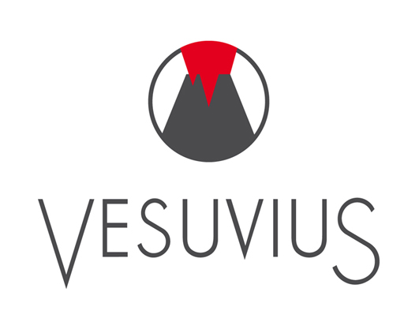
Vesuvius Flow Control, the world leader in ceramics and refractories related to the molten steel industry, is seeking Research Engineers with industrial experience to join the Flow Control research group at our new world-class Research center located in Belgium/Northern France Area

Mission:
The Research Engineers will reinforce Vesuvius technical leadership and business growth. They will apply Materials Science & Engineering concepts to develop new product/processes and to understand how refractory products behave in the steel making environment. They will lead medium/long term research projects involving both fundamental modelling and experimental validation.

Profile:
- Ph.D. in Materials or Ceramic Science/Engineering or related field. MSc&E candidates with significant Research Experience are welcome.
- 4-6 years materials research or new process/product development experience, including experience in industry.
- Hands-on experience in at least two of the following areas:
  - Ceramics or related materials (Refractories, Composites, Refractory Metals, Carbon)
  - Advanced material processing and links with microstructure and properties
  - Steel continuous casting
  - Thermodynamic modelling of high temperature systems
  - Finite element modelling (FEA, DEM, etc.)
  - Project management

At Vesuvius, a position in Research opens to varied career paths depending on each individual skills and career goals.

Vesuvius currently employs over 10,000 people and has 70 manufacturing plants in 40 countries throughout the world delivering “best in class” service to its customers on every continent.

Please forward application (CV + motivation letter) to:
Pierre Charreyron
Advanced Materials Resources
pierre.charreyron@centraliens.net

